Step 2 – Queries

Query 1:

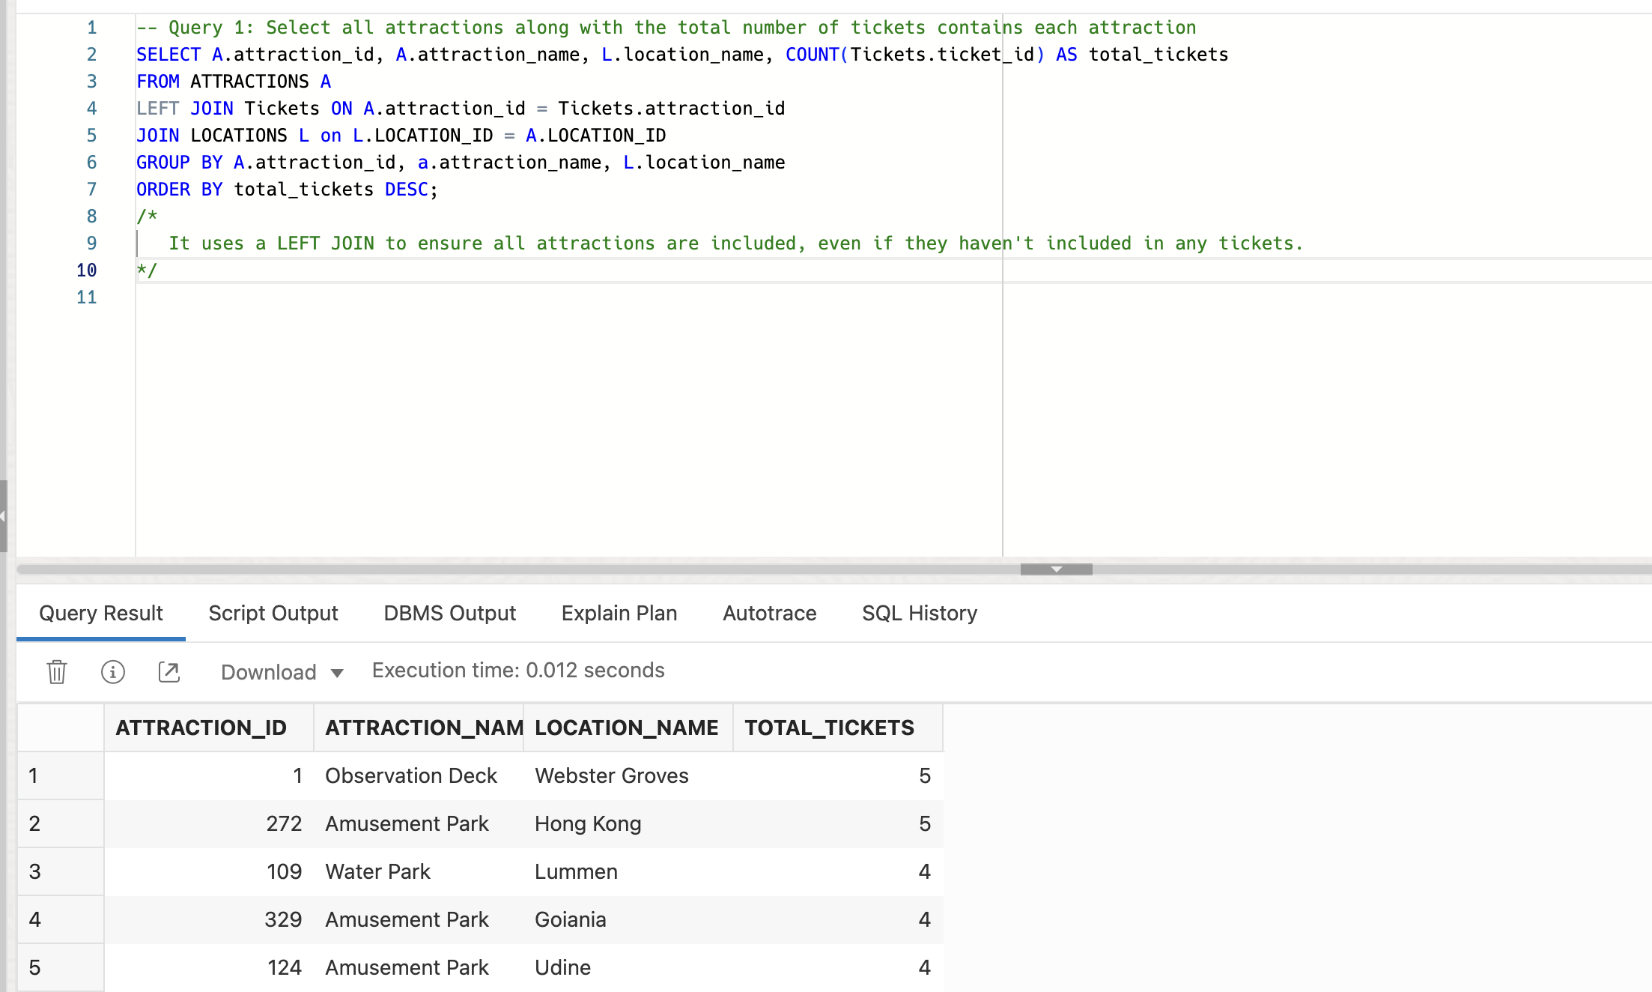

Query 2:

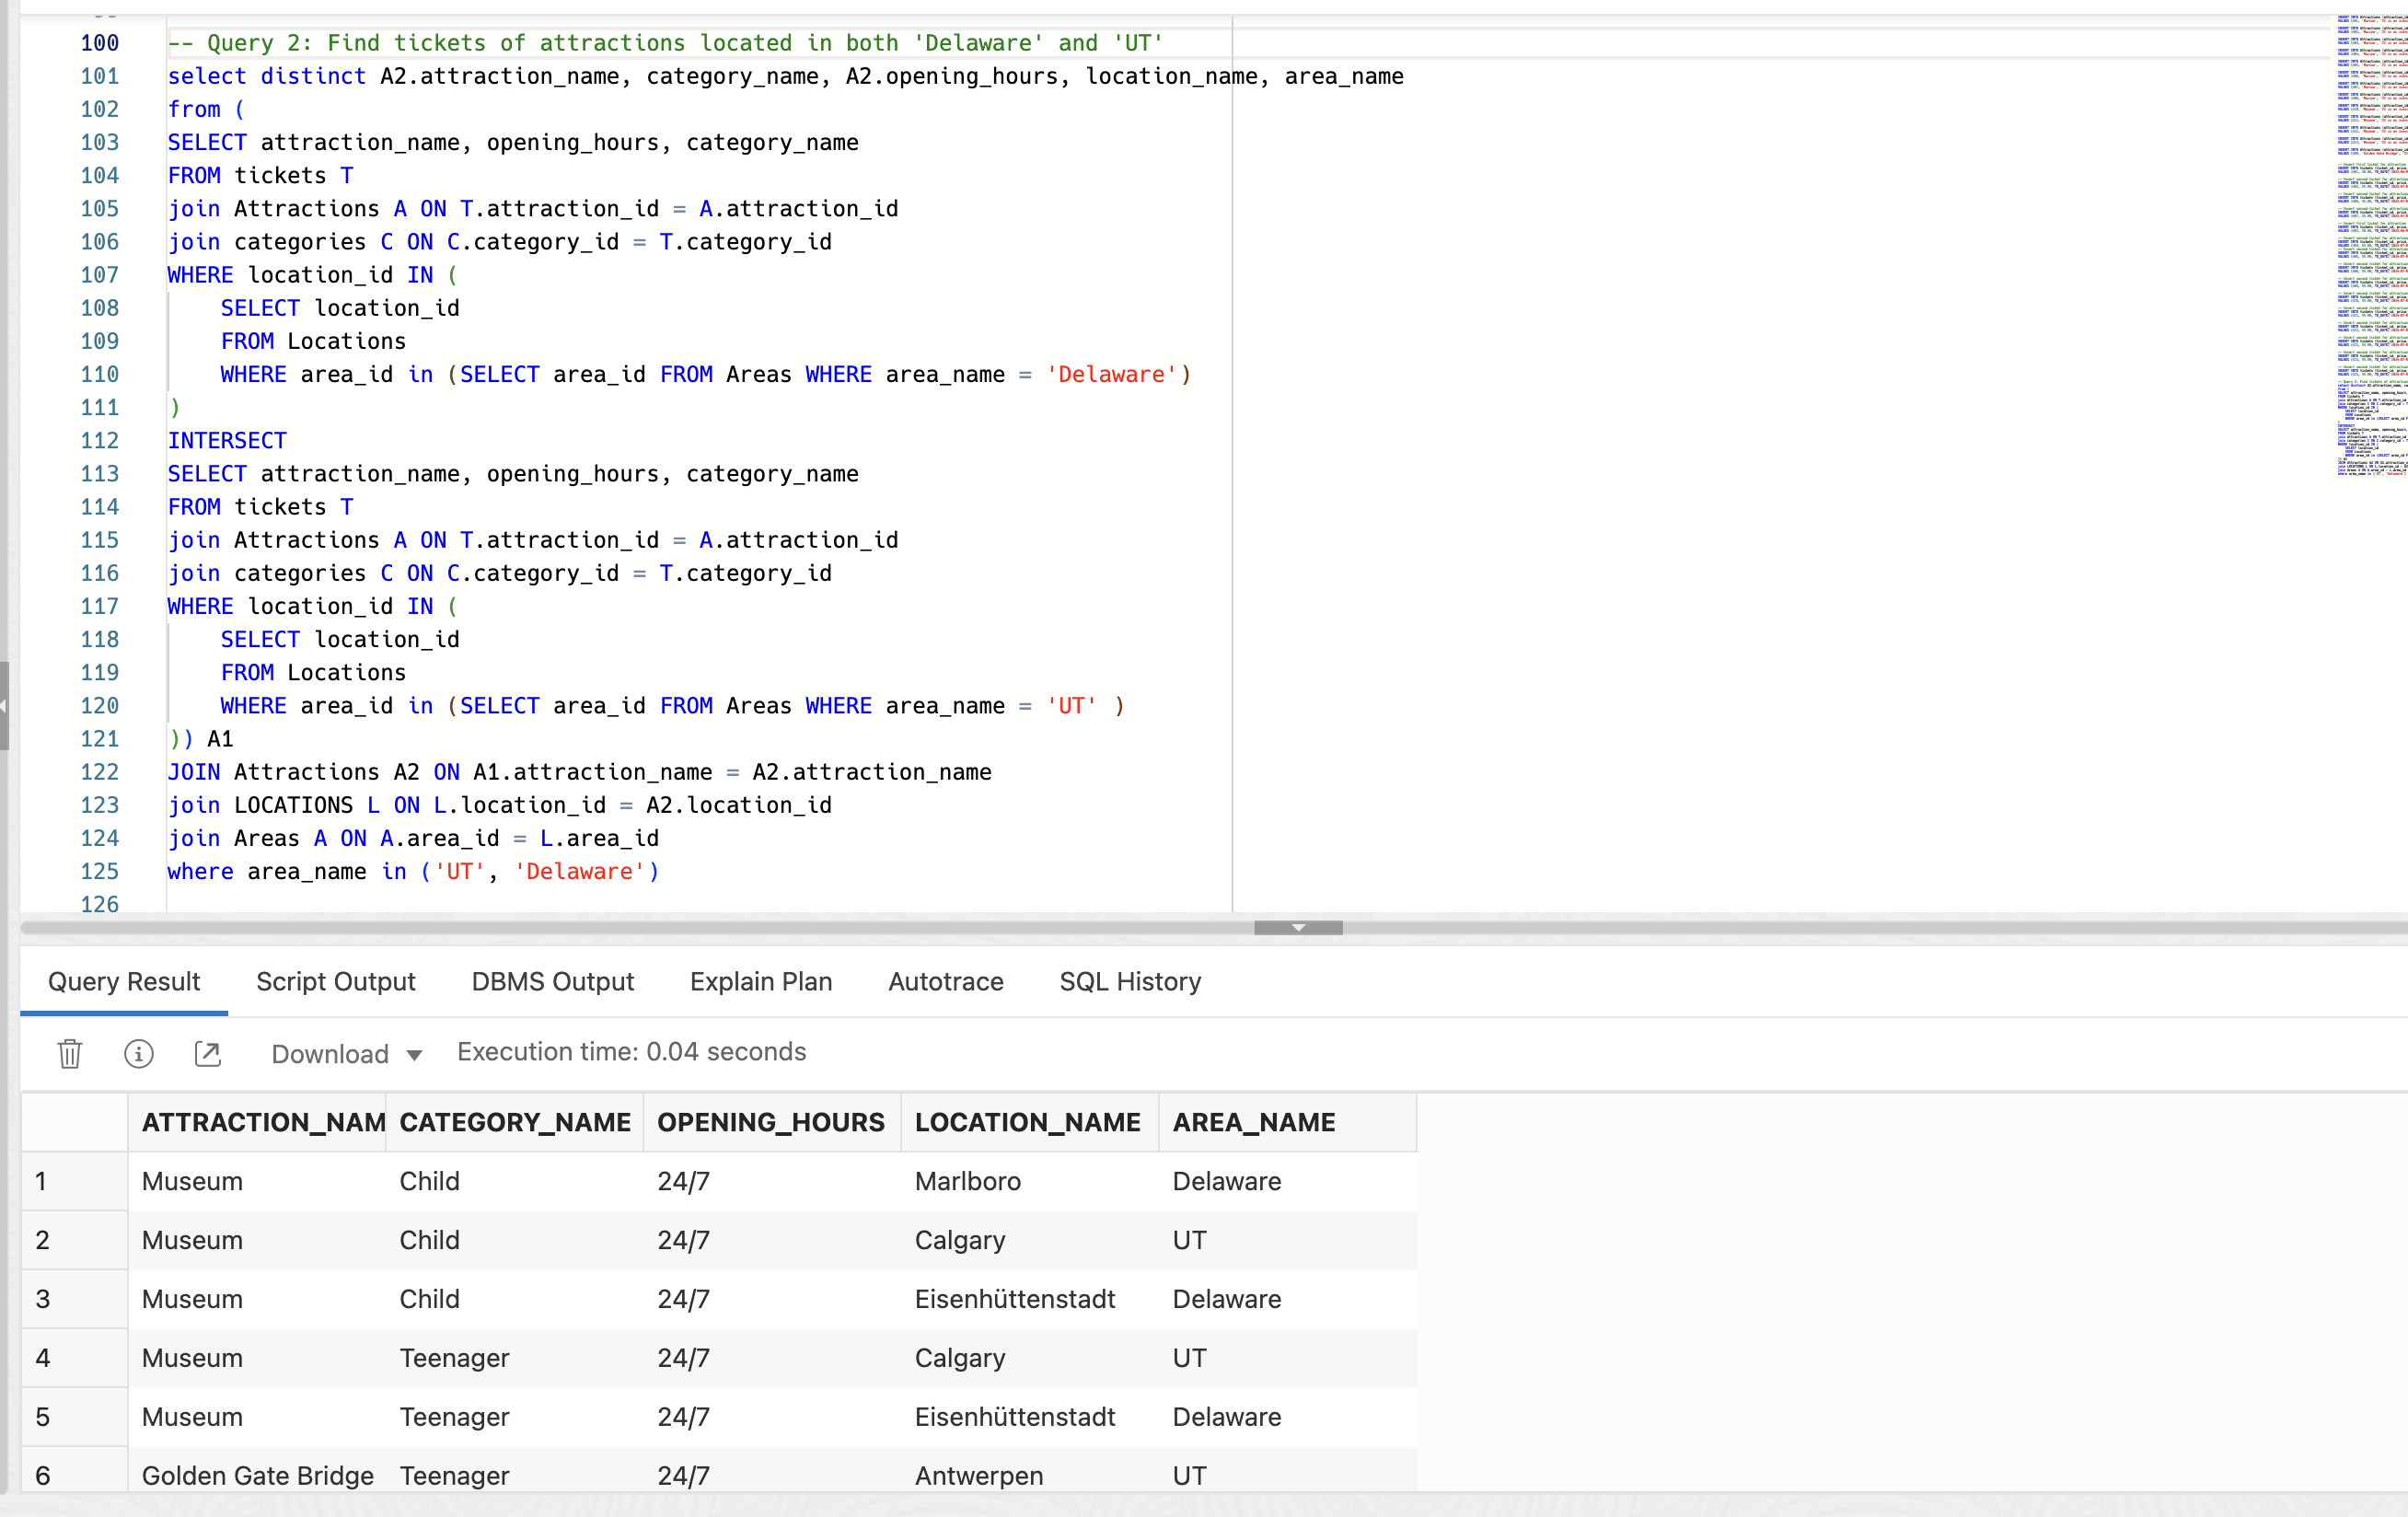

Query 3:

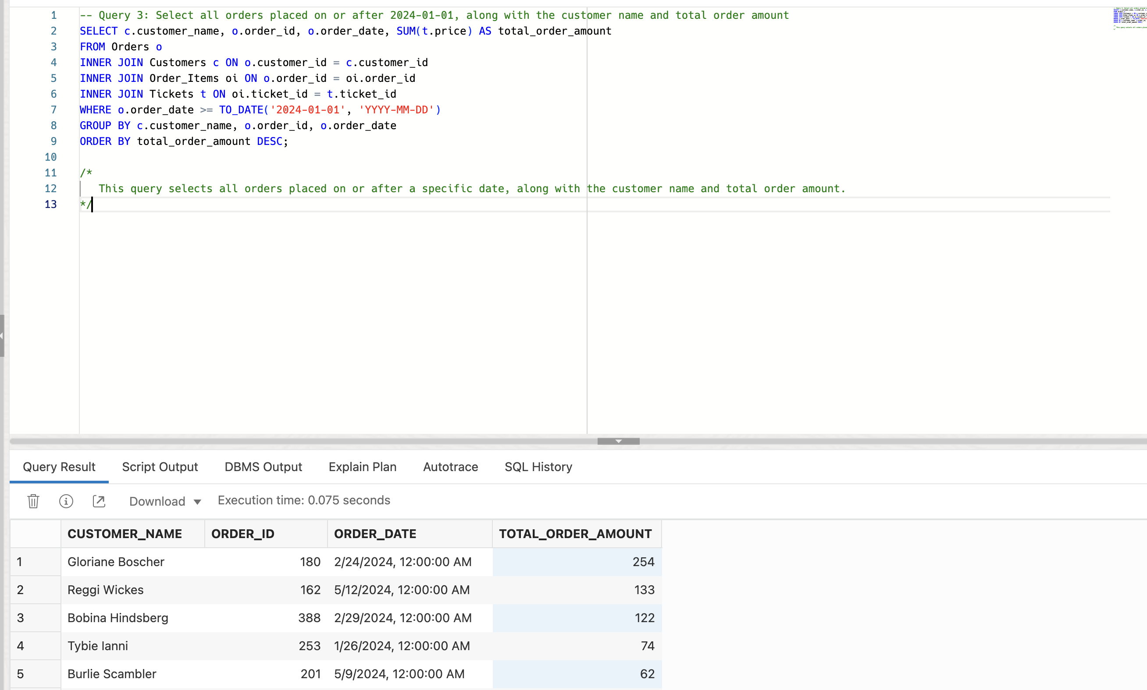

Query 4:

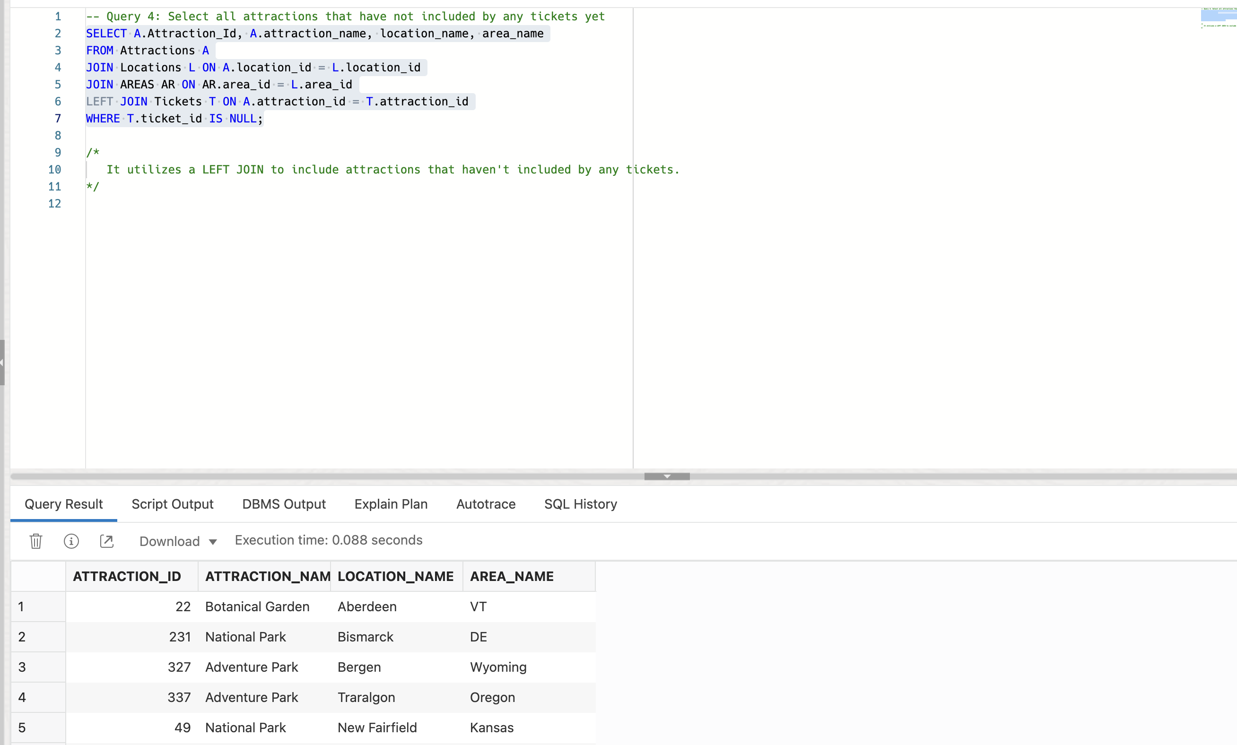

Query 5 – Before update:

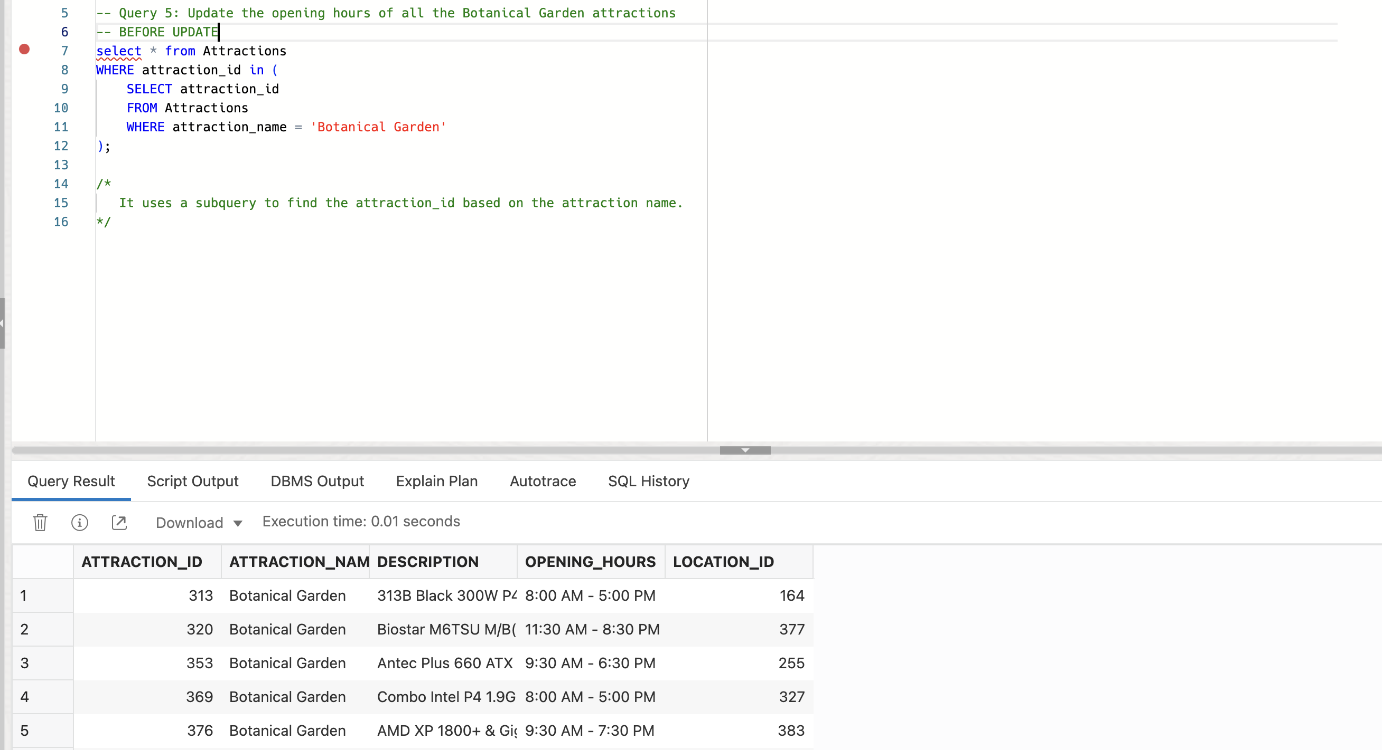

Query 5 – Update:

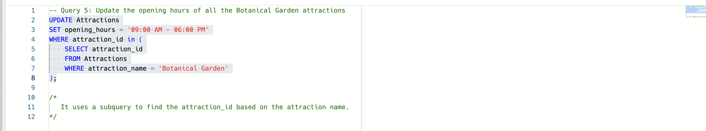

Query 5 – After update:



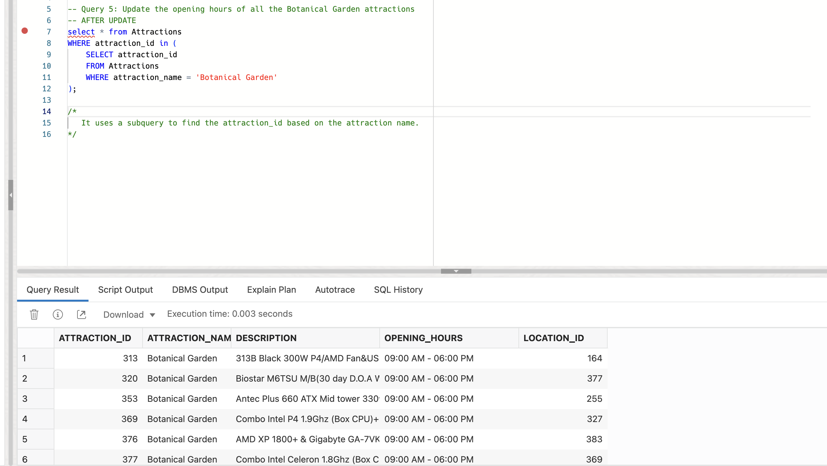

Query 6 – Before update:

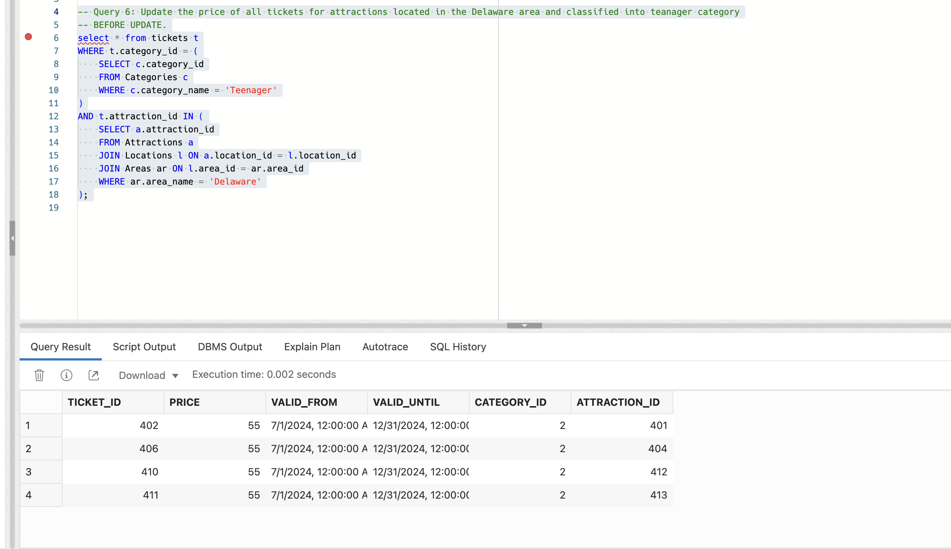

Query 6 – Update:

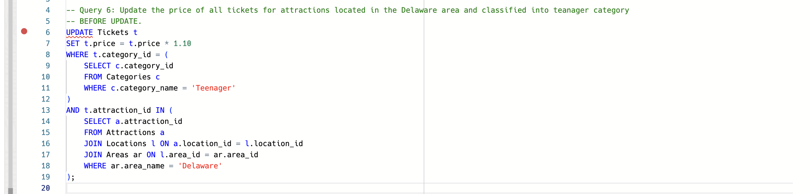



Query 6 – After update:

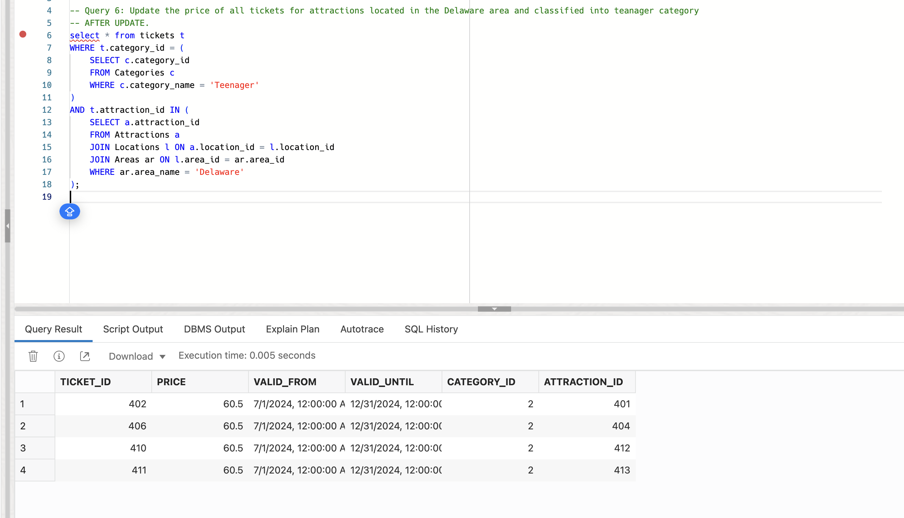

Query 7 – Before delete:

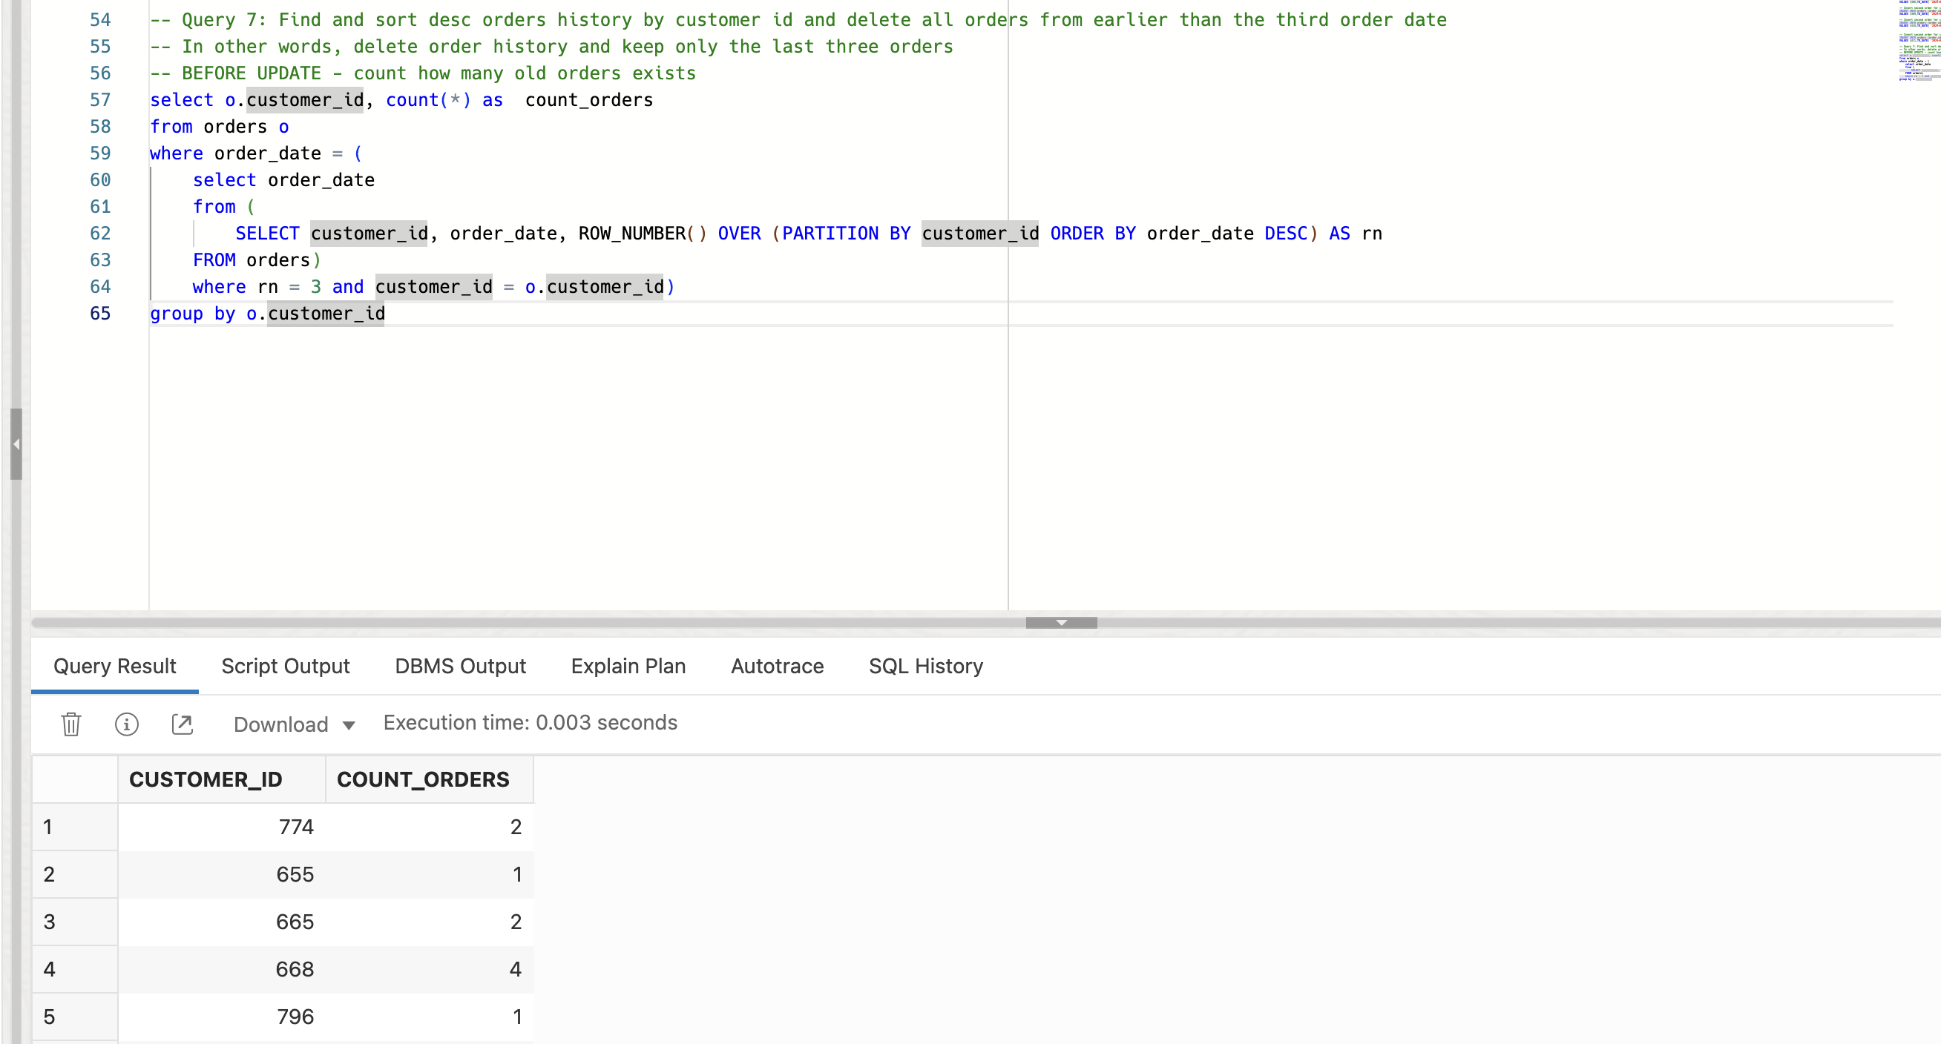

Query 7 – Customer 774 before delete:

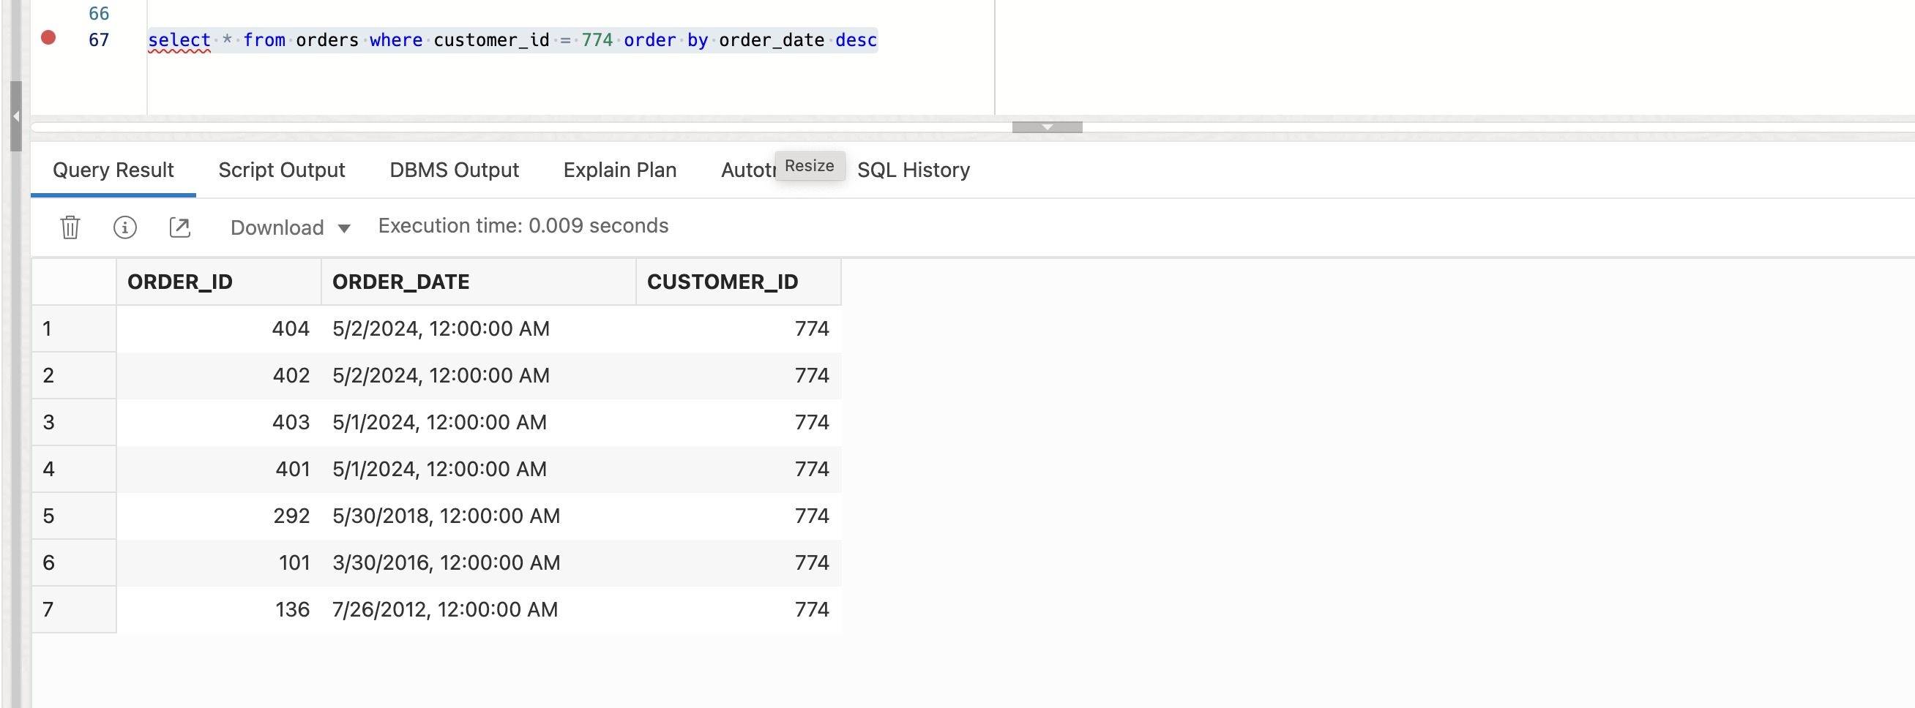

Query 7 – Delete order items before deleting orders:

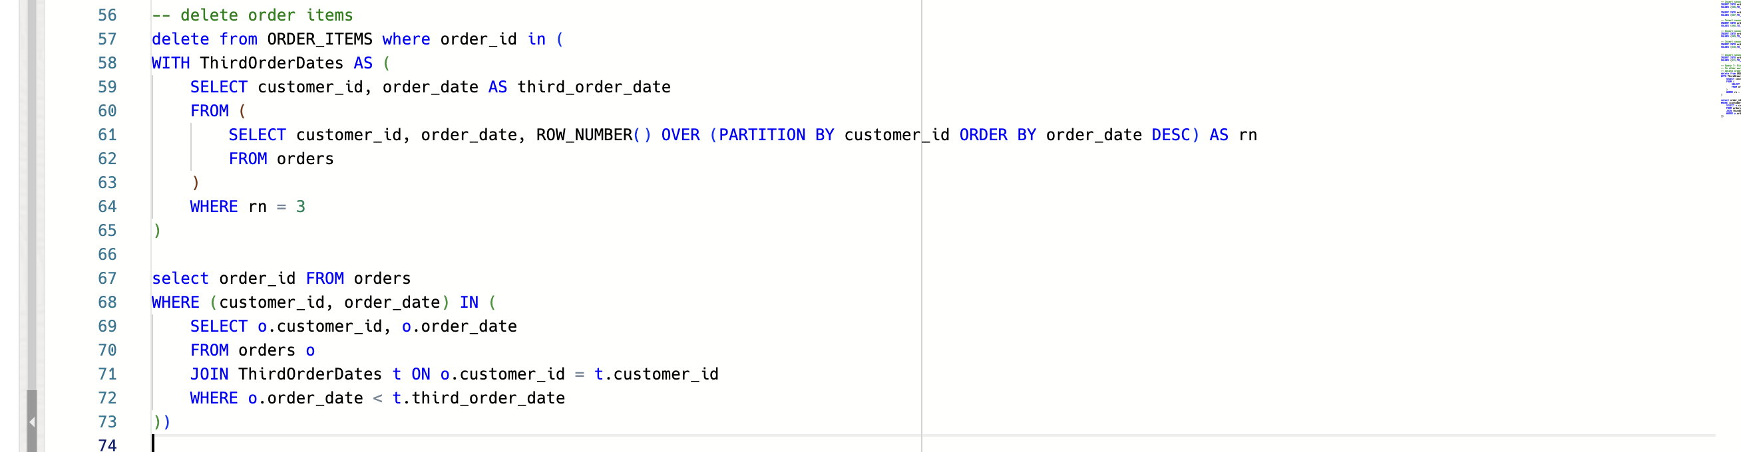

Query 7 – Delete:

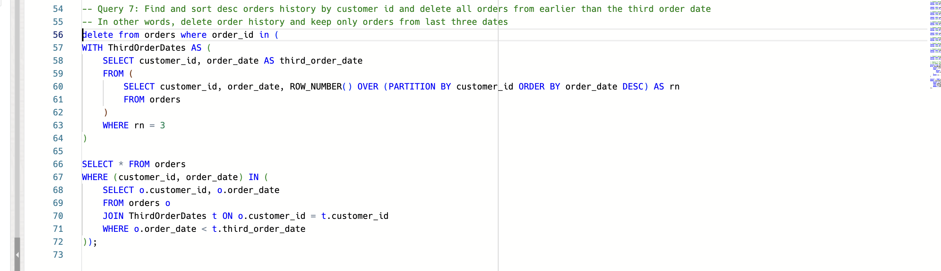

Query 7 – After delete:

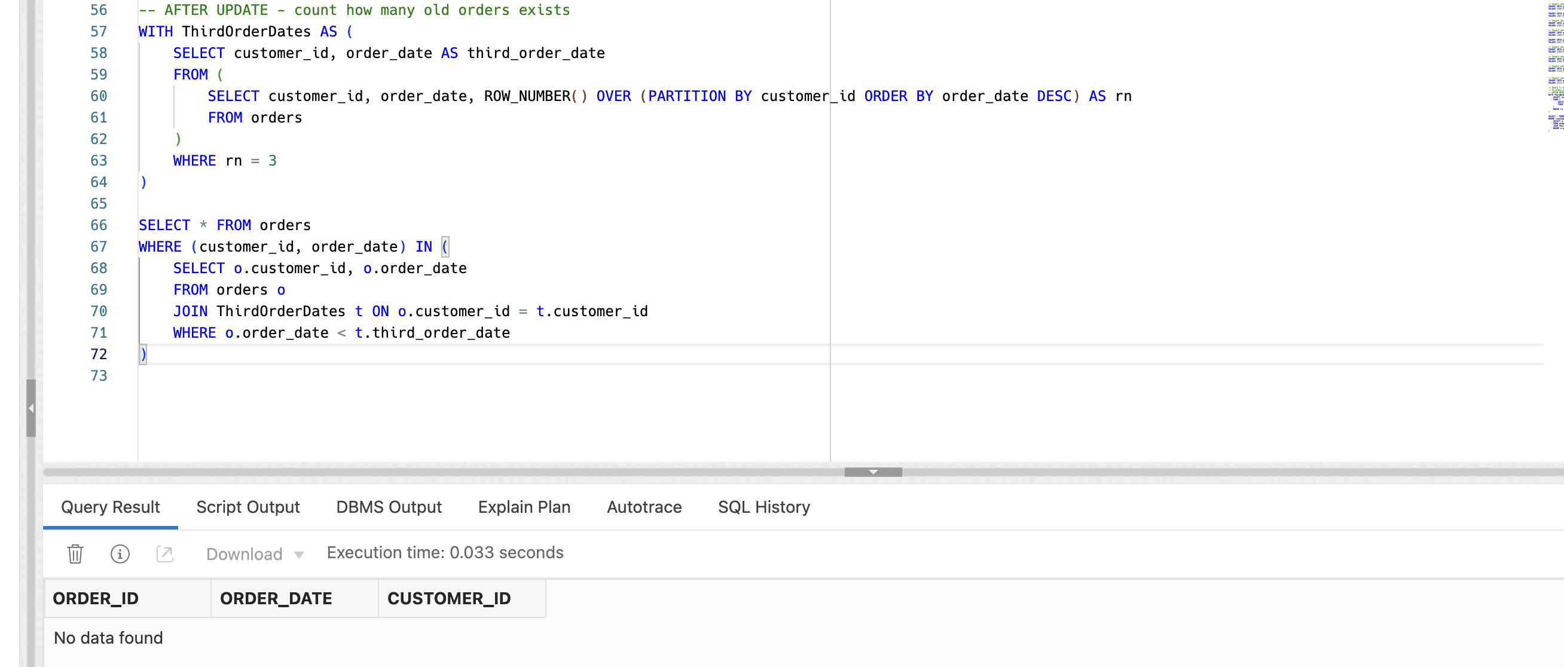

Query 7 – Customer 774 after delete:

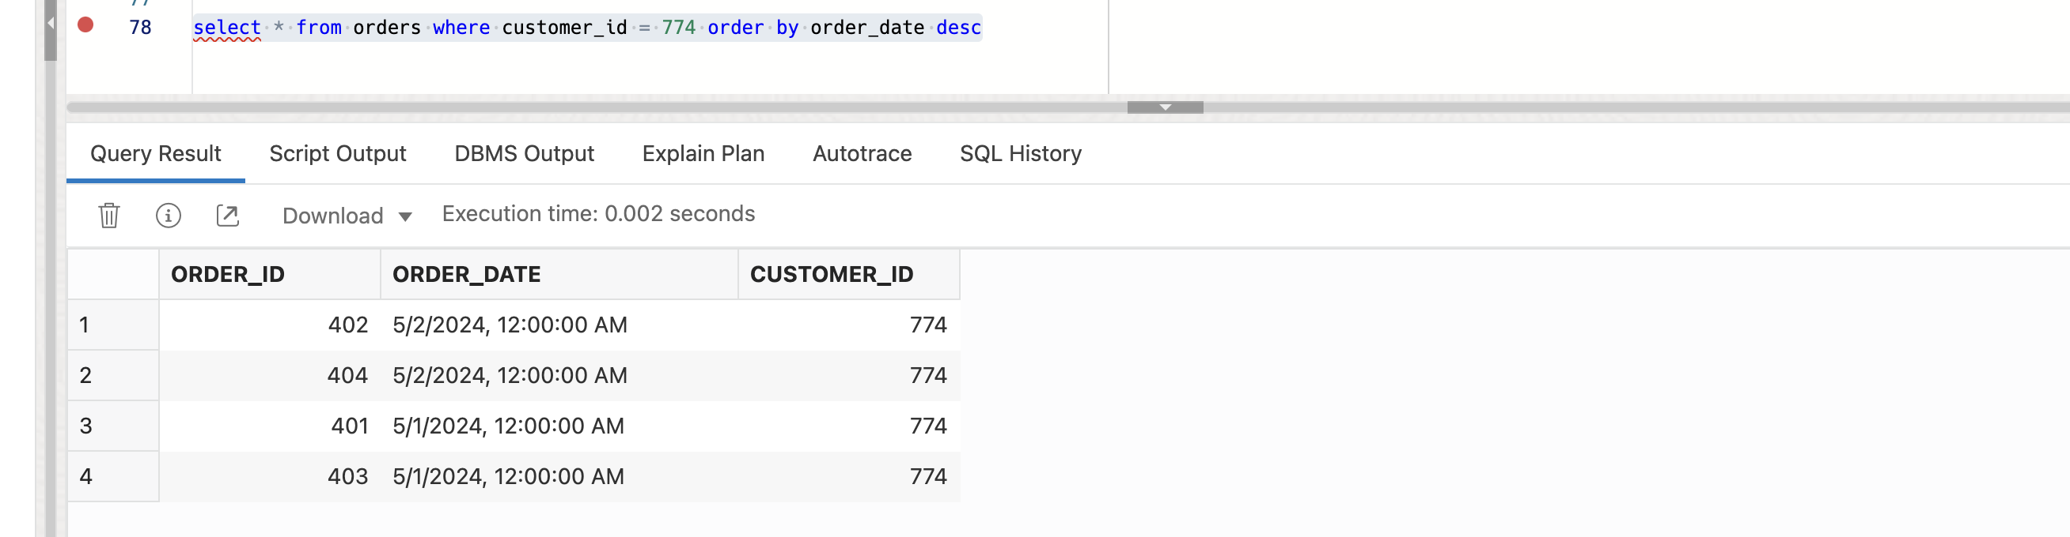

Query 7 – Table after delete:

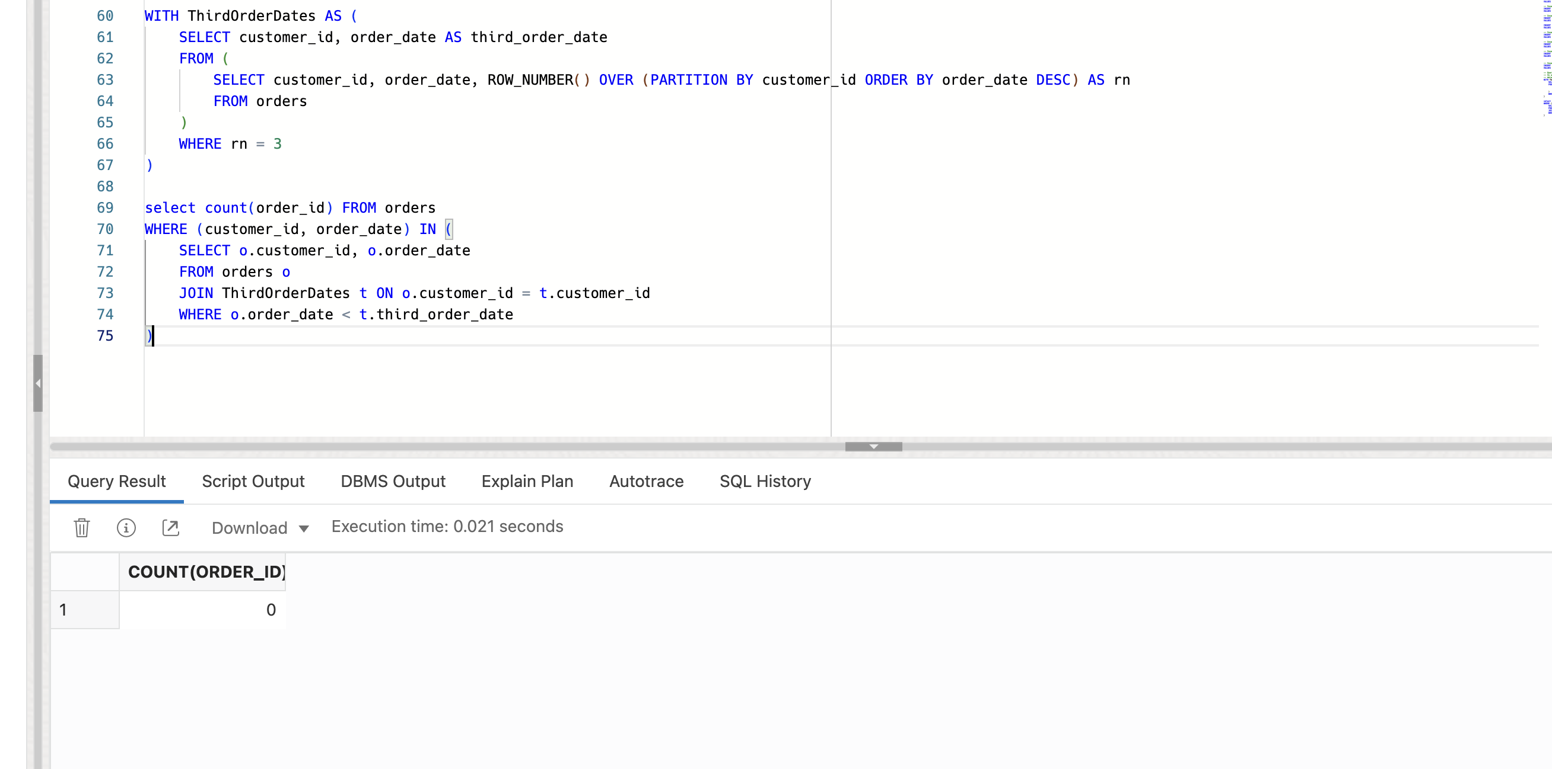

Query 8 – Before delete:

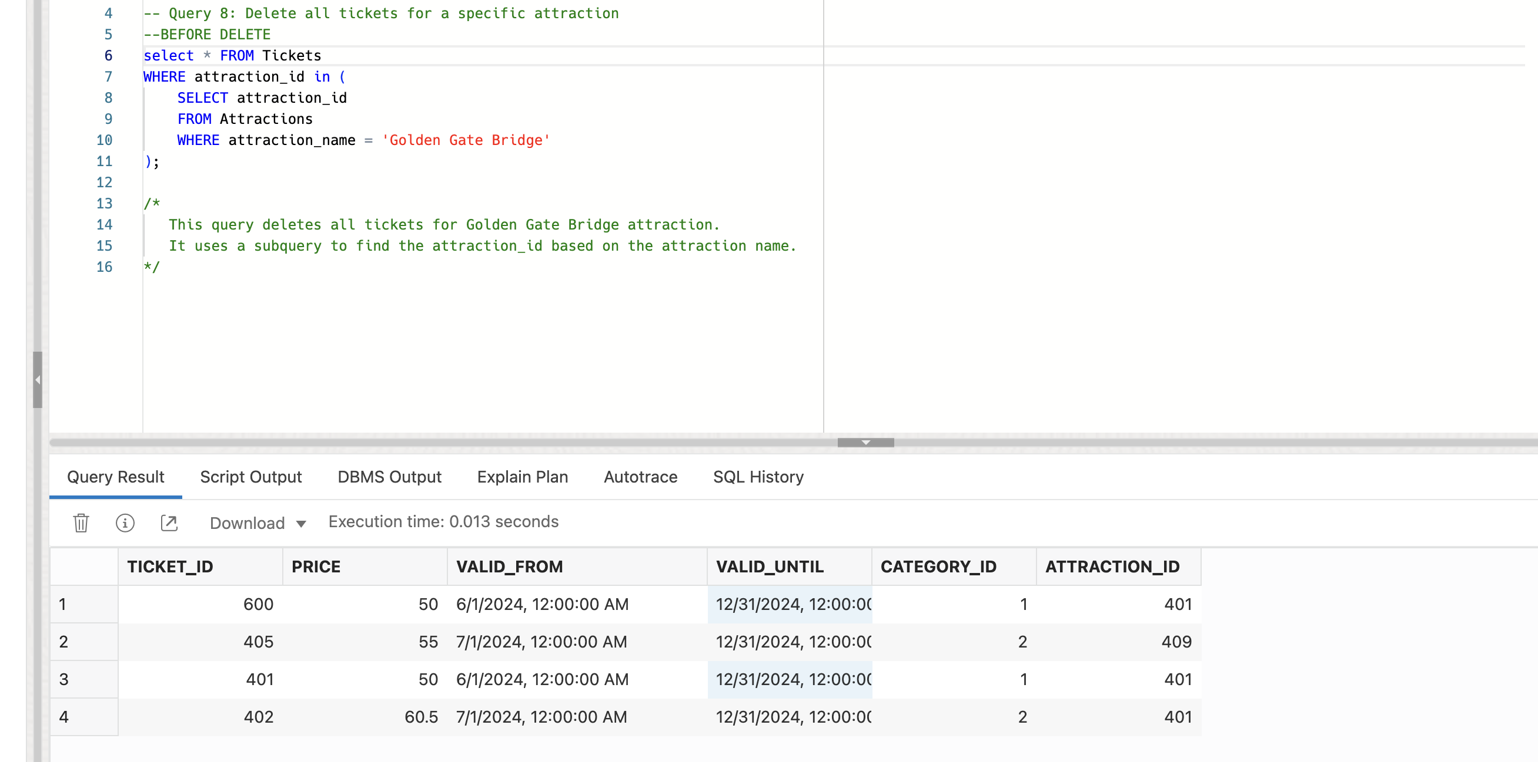

Query 8 – Delete:

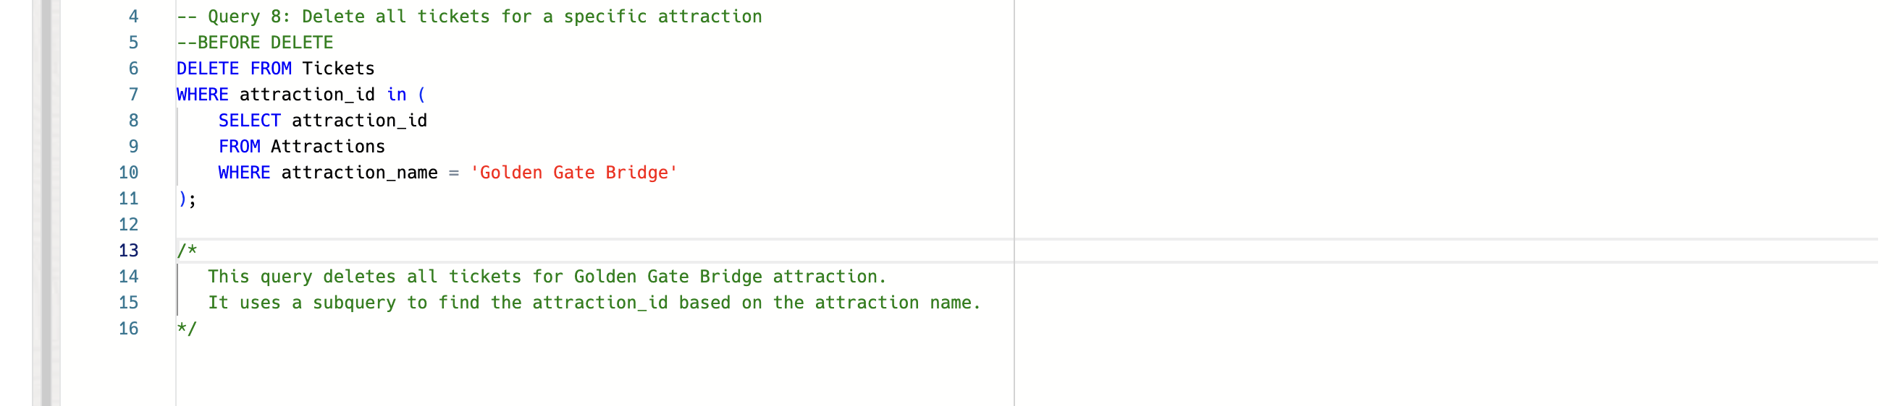

Query 8 – Table after delete:

